# **MP 0**

Ritvik Goradia (Goradia3)

Aumkar Renavikar (aar8)

Devul Nahar (danahar2)

Toby Liang (tobyzl2)

## Problem 5 (15 points)

The scenario displayed in the video below is for the car moving with a 15 meter sensing distance, 5 m/s initial velocity, 5 m/s2 deceleration, and 0 second reaction time.

Link to the video: <https://drive.google.com/file/d/1rp946Lu92KC5YV_kNa2hqCVb2LncUJ0R/view?usp=sharing>

The positions of the car (x1) and person (x2) in the x-direction are graphed below. The car comes to a halt approximately 10 meters before the pedestrian.

Note: distance is measured in meters and time is measured in seconds.

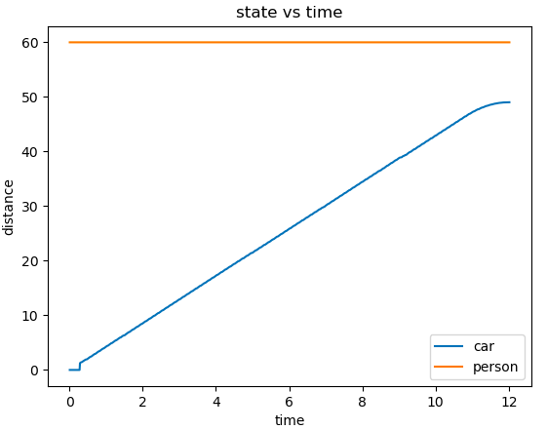

## Problem 6a

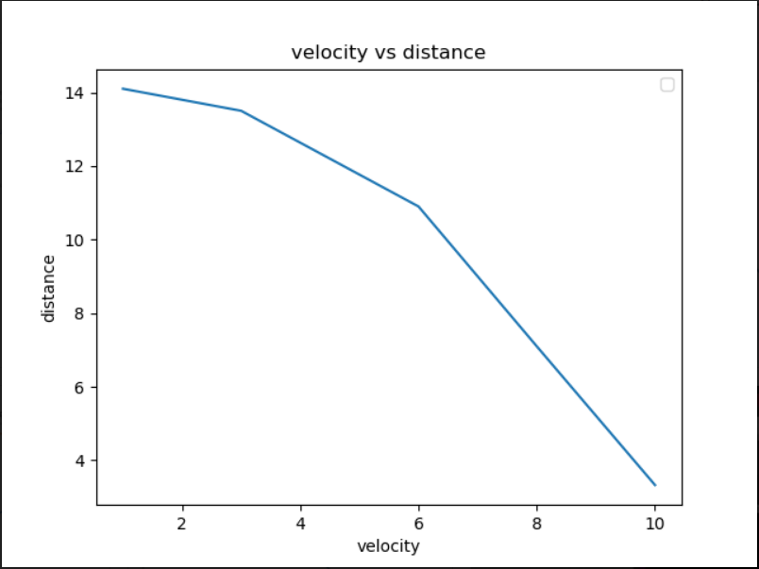

In this graph we see the distance of the car from the car at different initial velocities for the car. Specifically this graph shows the distance for initial velocities equal to 1 m/s, 3 m/s, 6 m/s, 8 m/s, and 10 m/s.

## Problem 6b

Yes, any velocity that we used that was above 10.5 m/s, ended up killing the person, making the car go haywire. If we used very large values for velocity like 100 m/s, then the car would not have enough time to sense the person and decelerate making the car go straight through the person. Once this happened the car would keep moving after it hit the person. This would result in the car sometimes moving outside of the environment setup.

## Problem 6c

When we tried to reduce d_sense, we found that the safety of the system also decreases since there is less distance to detect the person. Once the d_sense was small enough the car would behave in a similar manner to how it did in problem 6b. Note, however, that d_sense had a pretty large impact on whether the car killed the person or not. This makes sense as if there is not enough time to detect the person the car will not slow down and simply run over the person. Also note that having a large d_sense also means that the car could go at a much faster speed without killing the person.

## Problem 7

The scenario displayed in the video below is for the car moving with a 15 meter sensing distance, 5 m/s initial velocity, 5 m/s2 deceleration, and 1.5 second reaction time.

Link to the video:

<https://drive.google.com/file/d/1blSrYQ9dCb1zrhRn-bzyqXKmUGGAtTO6/view?usp=sharing>

The positions of the car (x1) and person (x2) in the x-direction are graphed below. The car comes to a halt approximately 5 meters before the pedestrian.

Note: distance is measured in meters and time is measured in seconds.

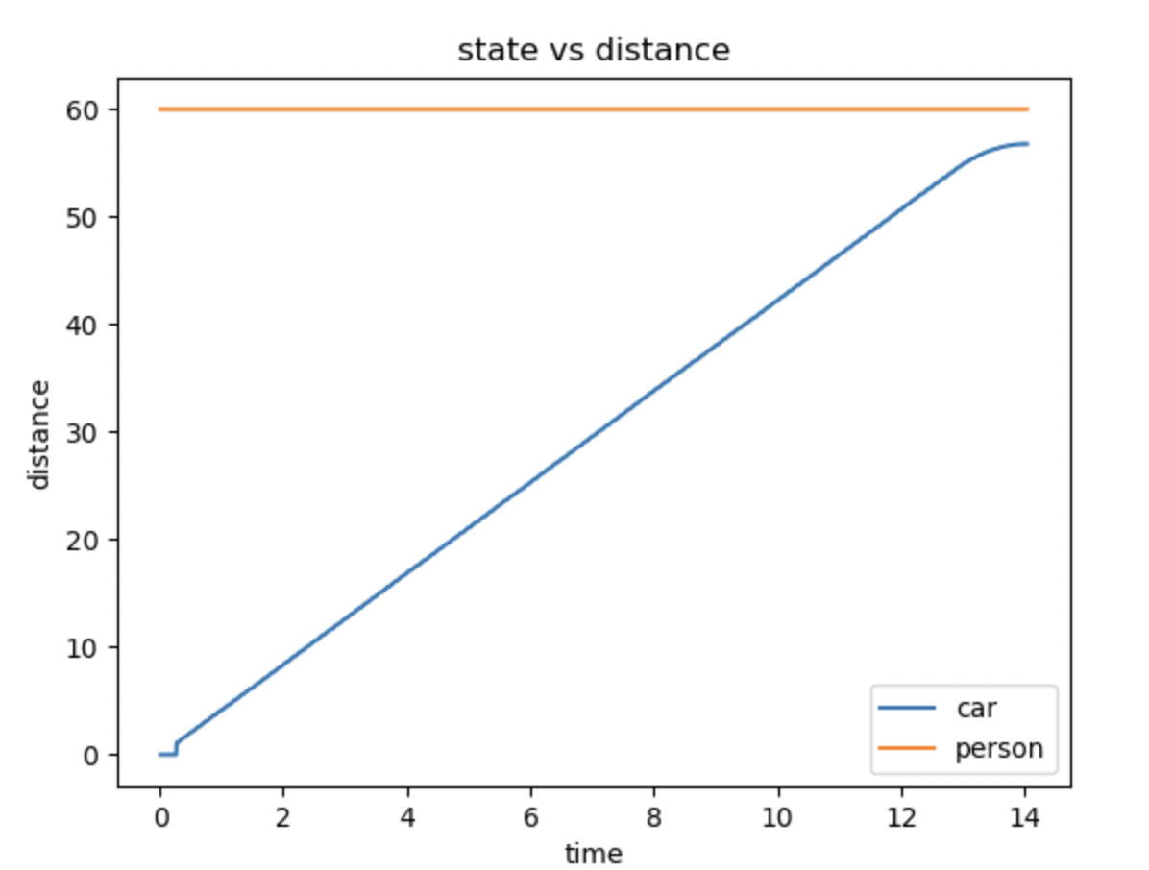

## Problem 8a

In our experiments we fixed our initial velocity to 5 m/s and chose different values of t_react to run our experiments. Specifically, we chose 0.5 s, 0.8 s, 1 s, 1.3 s, and 1.6 s as our values for t_react.

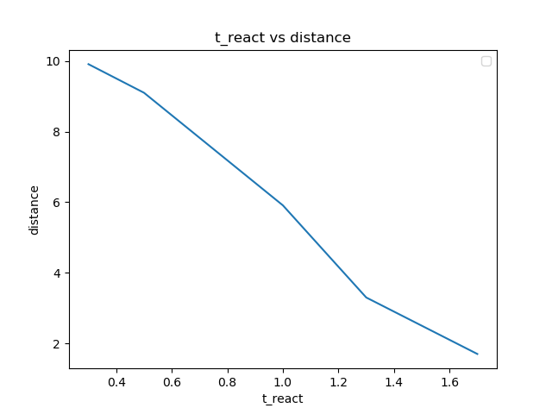

## Problem 8b

We found that if we allow the value of t_react to become greater than about 1.6 s, there would be too much of a delay before the brakes are applied, causing the car to run over the pedestrian. Intuitively, this makes sense because the greater the reaction time, the smaller the stopping distance, which would not give the driver enough space to stop after some threshold reaction time.

## Problem 8c

Compared to t_react, a_b has the opposite effect in that the safety of the system increases as a_b increases. In our experiments, we found that having a larger a_b allows the vehicle to brake faster, reducing the amount of space needed to stop. This can be used to counter the effects of a large t_react value since t_react reduces the space available for the vehicle to brake before hitting the pedestrian.